
Name: Janushiya P A
Reg No: 1924260368
Course Code: CSA0224
Course Name: C Programming

TASK 4 – USE MACROS SAFELY
Bloom’s Level: K4 – Analyse
1. Aim
To define safe C macros for repeated calculations and understand macro expansion, operator precedence, repeated argument evaluation, and the advantages of inline functions.

2. Algorithm
- Start.
- Define macros for converting rupees to paise, squaring a value, and finding the maximum of two values.
- Use parentheses to ensure correct operator precedence.
- Test the macros with sample values.
- Display the results.
- Compare macros with static inline functions.
- Stop.

3. Code

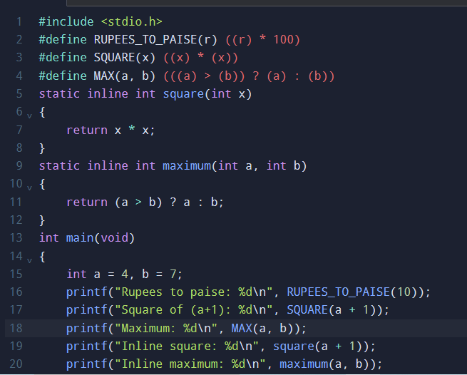

4. Output

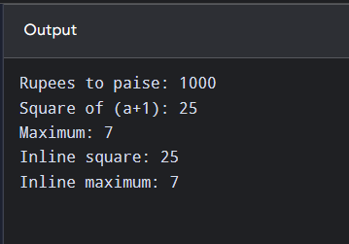

5. Explanation of Macro Pitfalls
a) Preprocessor expansion
The preprocessor replaces macro calls with their expanded expressions before compilation. The command below displays the expanded source code:
gcc -E task4.c
For example, SQUARE(a + 1) expands to:
((a + 1) * (a + 1))
b) Missing parentheses
If the macro is written as #define SQUARE(x) x*x, then SQUARE(a+1) expands to a+1*a+1. For a = 4, the result is 9 instead of 25 because multiplication has higher precedence than addition. Parentheses around the parameter and the complete expression fix this problem.
c) Repeated evaluation in MAX
The macro MAX(a, b) may evaluate an argument more than once. For example, MAX(i++, j) can increment i twice if i++ is selected by both the comparison and the final expression. Avoid side effects in macro arguments.
d) When a function is better
A function is better when arguments have side effects, type checking is important, or the calculation is complex. A static inline function provides normal parameter evaluation and clearer debugging.

6. Alternative Concept and Complexity Analysis
- Time: Both macros and inline functions generally perform a constant number of operations, O(1), for these calculations. A normal function call may have small call overhead, while an inline function may be optimized to avoid it.
- Code size: A macro is expanded at every use, so using it (k) times may duplicate its expression (k) times. An inline function may also be expanded by the compiler, but the compiler decides whether to inline it or retain a function call.
- Space: Macros have no independent runtime storage. Inline functions may generate a function body or duplicated instructions, depending on compiler optimization.

7. Result
Safe macros were implemented using parentheses to avoid operator-precedence errors. The program demonstrated rupees-to-paise conversion, squaring, and finding the maximum value. The use of gcc -E shows how macros are expanded before compilation, and inline functions provide a safer alternative when repeated argument evaluation is a concern.

